1. What is Tableau Data Engine?

* It is also used for cross-database joins to support federated data sources with multiple connections.

1. How to create a calculated field in Tableau?

* In Tableau, go to Analysis, then go to create Calculated Field, type the formula and press OK to confirm

1. Can you tell the differences between TreeMap and Heat Map?

* Treemaps are represented by the different dimensions, so that the user can identify the quantitative measures.
* Heatmaps are used in analysing the patterns.

1. What are the components of a dashboard?

* Tables, Charts,

1. How much sales have come from customers from the previous in the

current year in terms of Sales Value?

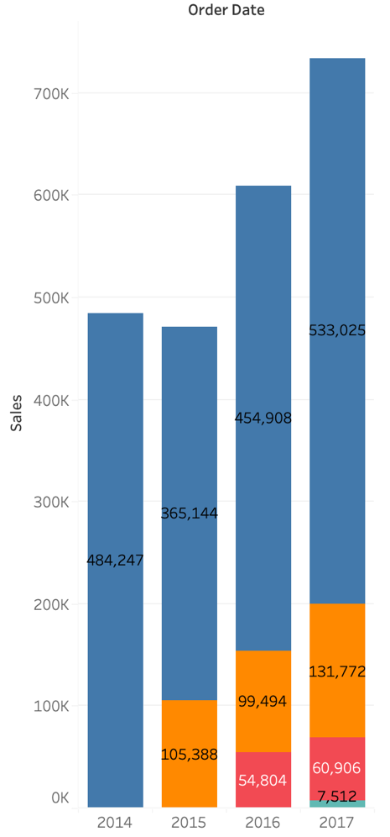

How much sales have come from customers from the previous in the

current year in terms of Sales Percentage?

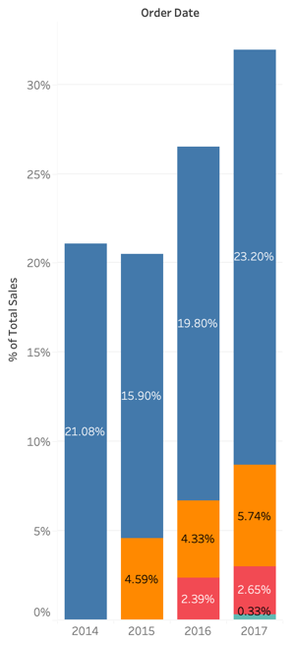

Find the orders placed by each customer.

